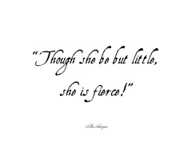
Lysander
Midsummer Night’s Dream - BC

Lysander is a noble man who is in love with Hermia and is running away with her to his aunties. He also is Demetrius’s enemy because he tried taking Hermia of off him. Overall he is a very sweet guy and a perso who will always help. Lysander’s relationship with Hermia invokes the theme of love’s difficulty.

Hippolyta
Hippolyta as you know is the Amazonian queen who is protected by fairies and is Theseus’s lover. She has normal boy who she treats as her son and is very strict woman. And overall she’s very kind but rough and is extremely adventurous.

Puck

Puck is a troublesome hob goblin who serves Oberon. Also known as Robin Good fellow, Puck is Oberon’s jester, a mischievous fairy who delights in playing pranks on mortals. Even though he sounds nasty he does have a bright side. Just like how he helped build the love triangle.

Overall it’s a great and confusing play to re-enact.
#the course of true Love never did run smooth.

