Hermia
Hermia is the daughter of a powerful Athenian nobleman. She’s probably one of the most spoiled girls of all the Athenians. She defies her father by running away to the forest away from the law. Lysander is the real love of her life not Demetrius. They went to Lysander’s auntie’s house to get married.
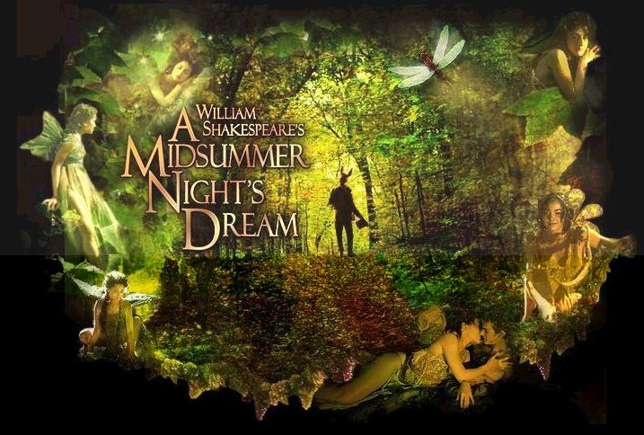
Helena
Helena thinks she’s as ugly as a bear. She is in love with Demetrius but he used to love her, but now he’s disgusted by the fact that she thinks she’s ugly. She thinks she’s so ugly she scares off monsters. There all mixed up in a giant love triangle were Helena loves Demetrius but he loves Hermia but Hermia loves Lysander.
Hippolyta
Hippolyta is the queen of the Amazons. She’s a fierce warrior who was to be married to Theseus. She actually lost a war against the duke of Athens and is now married to him. While Theseus was worried she was exited to marry and hopes the days all go quickly.

