HERMIA

Rhiannon Bartlam

Hermia is a daring young mistress who knows her own mind, she stands up for herself. Her mind is telling her to marry Lysander, but her dad (Egeus) commands that she marries Demetrious a warrior, but she doesn’t love him, in fact, her best friend Helena is in love with Demetrious but he despises her!!!!!!! Hermia most definitely gets her own way all the time and she acts like a big brat, and she plays a very spoilt person. Personally I think she is fiery, she has a bad temper, and a very bad attitude. Helena has been afraid of her since they were little, at school.

DEMETRIOUS

Demetrious is a troubled warrior who is madly in love with Hermia and desperately wants to be wed to her, but obviously she refuses so it can’t be a happily ever after. He is a show-off in front of everyone, he and Theseus has come up with a plan to give Hermia a choice, she either marries Demetrious, gets executed or she will get sent to nunnery for the rest of her life!

PUCK

A mischievous gobbling ‘puck’. Puck is a no good gobbling who likes making mischief and he loves playing pranks on people, he has many talents up his sleeve (magic) like turning invisible, that allows him to do magic on someone without anyone noticing. He can also girdle the earth in forty minutes.

TITANIA

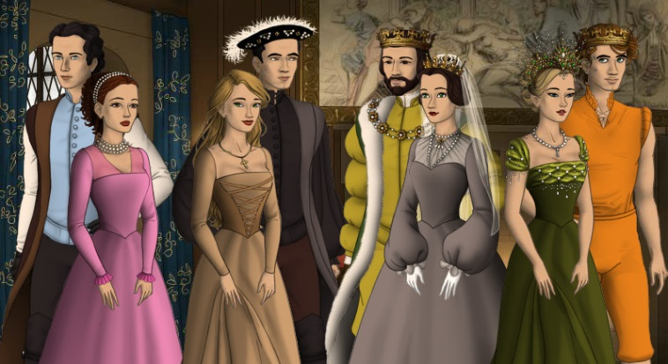Titania is the queen of fairies, she is a strong and powerful woman/fairy who always keeps her promises. Despite being in love, her and Oberon can and do have their disagreements and differences. You may expect fairies to be polite and gentle but she’s more like a mad and slightly crazy dragon.